MODAL VERB

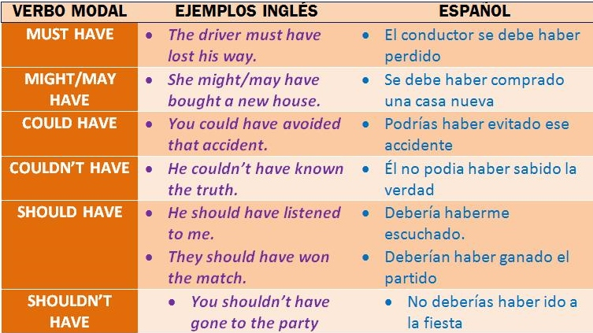

CANT HAVE

Can't have + past participle: Se usa este perfect modal para indicar una imposibilidad en el pasado o para establecer una conclusión negativa en la que estamos seguros o casi seguros de que un hecho pasado no sucedió. Da la idea, en definitiva, de que algo no pudo haber pasado.

ejemplos:

**He can't have passed the exam.**

**Él no puede haber aprobado el examen.**

**It's not seven. The film can't have finished.**

**No son las siete. La película no puede haber finalizado.**

COULD HAVE (podría)

Subject+Could have + past participle: Se usa para indicar que algo pudo haber pasado o pudo hacerse pero que al final no sucedió o no se hizo.

ejemplos:

**You could have finished the cake.**

**Podías haber terminado la tarta.**

**They could have gone with us.**

**Podían haber ido con nosotros.**

COULDNT HAVE (no podría)

Couldn't have + past participle: con este perfect modal deducimos con cierto grado de certeza que un hecho pasado no ocurrió o al menos suponemos que no ocurrió.

ejemplos:

**Peter couldn't have written that speech.**

**No es posible que Peter haya escrito ese discurso.**

**It couldn't have rained during the night.**

**Puede que no haya llovido durante la noche**.

MIGHT HAVE (podría)

Subject +might + have + past participle: con estos perfect modals expresamos suposiciones y especulaciones sobre hechos pasados.

ejemplos:

**They may / might have been here.**

**Puede que ellos hayan estado aquí.**

**It may not / might not have rained.**

**Puede que no haya llovido.**

MUST HAVE (debe)

Subject +Must + have + past participle: expresamos una deducción o conclusión lógica sobre un hecho pasado del que estamos seguros o casi seguros.

ejemplos:

**He's studied a lot. He must have passed the exam.**

**Élha estudiado mucho. Tiene que haber aprobado el examen.**

**It must have rained during the night.**

**Tiene que haber llovido durante la noche.**

SHOULD HAVE (debería)

Subject +Should + have + past participle: se usan estos perfect modals para opinar sobre sucesos pasados manifestando crítica sobre el hecho de no haber seguido un consejo.

ejemplos:

**You should have done the shopping.**

**Deberías haber hecho la compra.**

**Mark ought to have travelled to London.**

**Mark debería haber viajado a Londres.**

**SHOULDN´T / SHOULD NOT ( NO DEBERÍA)**

Should not / Shouldn't + have + past participle: expresa arrepentimiento o una crítica sobre un hecho pasado.

ejemplos

**I shouldn't have said that.**

**No debería haber dicho eso.**

**Steve shouldn't have bought that computer.**

**Steve no debería haber comprado ese ordenador.**

EXAMPLES:

I must have gone to the dentist last week. (Yo debo haber ido al dentista la semana pasada)

She must have gone to the beach with us. (Ella debe haber ido a la playa con nosotros)

He could pay more attention to what the teacher says. (Él podría poner más atención a lo que dice el maestro)

You could go out more often. (Tú podrías salir más a menudo)

You could publish your book next year. (Tú podrías publicar tu libro el siguiente año)

You should call her tomorrow. (Tú la deberías llamar mañana)

You should see her tomorrow. (Tú deberías verla mañana)

write 10 sentences using the modal perfects

He should give me money for my birthday.

She must have gone to the church.

I could have dated with her.

You shouldn’t drive drunk.

It couldn’t have happened.

I shouldn’t have done that.

He must have arrived early yesterday.

I may have done that.

You could have come here .

She must have a lot of work.

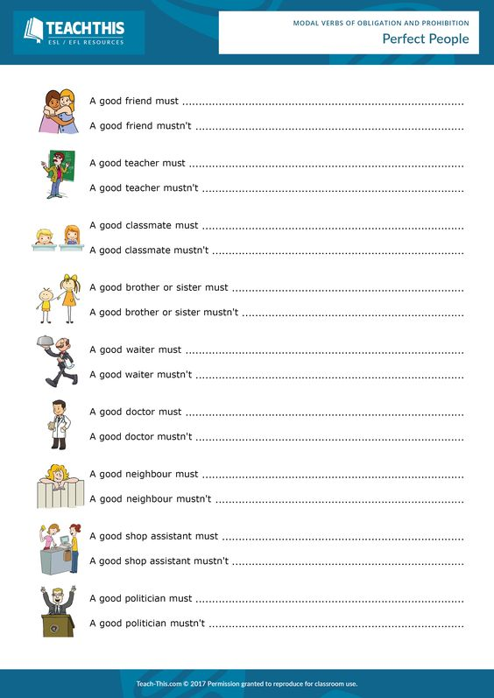

Have attacked with anything.

have buy exaclty everything on the list.

have get high.

have listened his people.

have stole our cashback.

have thrown her trash on our yard

have spend time with us.

have worked in fatigue.

have be ethical.

have demand tip.

have provide good service.

have helped in our entire life.

have hit us.

have be able to work in a team.

have give us the answers for the quiz.

have know a lot.

have betrayed us.

have spend time with us.